INTERNATIONAL CRITICAL INCIDENT STRESS FOUNDATION, INC. (ICISF)

Individual Crisis Intervention
Course Goals & Objectives
- Explain the four fundamentals of crisis intervention tools necessary during a critical incident by a caregiver.
- Learn and demonstrate the technique of active listening – attending, positioning, questioning, and informing.
- Demonstrate the importance of good listening skills. Demonstrate technique of active listening Open vs. Closed-Ended questions.
- Describe common psychiatric symptoms after trauma.
- Demonstrate cognitive reframing techniques and peer support role.
- Describe the key markers for basic grief, major loss, and suicide.
- Learn common element of CISD and group dynamics theory.

Group Crisis Intervention
Course Goals & Objectives
- Explain the nature of stress as it relates to critical incidents for clients and caregivers.
- Learn common psychological and behavioral reactions to stress at the time of a critical incident.
- Learn the key terms and concepts used by the International Critical Incident Stress Foundation (ICISF).
- Describe the basic interventions for Critical Incident Stress Management.
- Know the key points of strategic planning for a response.
- List the key elements of demobilization, crisis management debriefing, defusing and debriefing.
- Describe the organizational structure of a team and the rationale for the structure.

AGENDA
Friday, November 8, 2013 &
Saturday, November 9, 2013 &
8:00 AM – 5:00 PM
1 hour lunch

Sunday, November 10, 2013
8:00 AM – 4:30 PM
1 hour lunch

CORE TRAINING
This training is the core education needed to be a member of the Polk County Mental Health Response Team.

LOCATION
This workshop will be held at:
Iowa DCI Crime Laboratory
2240 S. Ankeny Blvd
Ankeny, IA

DIRECTIONS
Enter the DMACC Ankeny Campus from Oralabor Road. The DCI Lab is located in the Iowa Laboratory Building – West side of the Road.

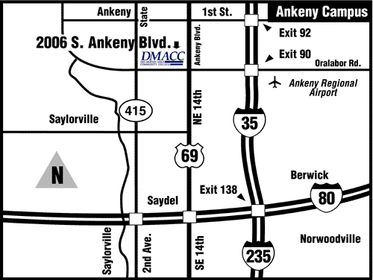

QUESTIONS
Contact:
Polk County Mental
Health Response Team,
Volunteer Clinical Coordinator
Margie Conrad, BS
Phone: 515-480-6880
Cell: 515-954-0409

INSTRUCTOR
MARGIE CONRAD, B.S.

Margie Conrad serves as a consultant and mental health coordinator for Polk County Mental Health Response Team sponsored by Polk County Health Services. The team mission is to help the community and individuals recognize & cope with the emotional aftershocks of disasters & critical incidents. She has serves as International Critical Incident Stress Foundation (ICISF), Inc., Instructor and Regional Liaison for Iowa, Illinois, & Indiana.

Having been raised in an emergency services family, Margie has real life experience in the field of trauma. She has 25 years in a variety of settings providing peer counseling and crisis intervention. As a staff member of the American Red Cross Margie spent 21 years with a focus on Crisis Intervention/Disaster Mental Health, Program Development, and Volunteer Coordination. She also participated in the Enduring Family Program providing services for Military and their Families. Margie has worked as a member of the MERCY DMAT Medical Team, and is a member of the Iowa DBHRT and also is a member of the IA-DMOT Team.

TARGET AUDIENCE
Caring, supportive community members, peer counselors, advocates, para-professionals, Social workers & other mental health professionals, including marriage & family therapists, mental health counselors, psychologists & psychiatrists, nurses, emergency responders, police &fire personnel.
Registration Form

To register, complete this form and return to: Polk County Health Services by November 1, 2013. Seating is limited to 30 participants.

SPECIAL ACCOMODATIONS: For those requiring special accommodations to permit participation, please provide a written request along with your completed registration form and payment by November 1, 2013.

Location is handicap assessable.

Name

Address

City, State, Zip

Home Phone

Work Phone

E-mail
Registration Fee PER PERSON
$130 (Fee includes materials)

Credit Card Type_____________________
#__________________________________
Exp. Date: ____/____

___________________________________
Card Holder Signature

Make Checks Payable To:
Polk County Health Services
Check #:__________

Send To:
Margie Conrad
1800 Grand Avenue, Apt. 390
West Des Moines, IA 50265

Sponsored By

POLK COUNTY
HEALTH SERVICES, INC.

LOCAL AREA HOTELS

Best Western,
133 SE Delaware Avenue
515-964-1717

Country Inn & Suites,
2510 SE Tones Drive
515-965-2646

Holiday Inn Express
2402 SE Tones Drive
515-965-2400

International Critical Incident Stress Foundation, Inc. (ICISF)

Individual Crisis Intervention
&
Group Crisis
Intervention

November 8,9,10,2013
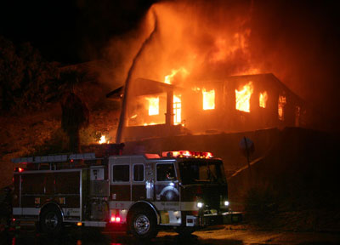
Instructor
Margie Conrad, B.S.

Iowa DCI Crime Laboratory
2240 S. Ankeny Blvd
Ankeny, IA

27.00 CEU hours available

